CHAPTER 3
Data Modeling Using the Entity-Relationship (ER) Model
Copyright © 2017 Ramez Elmasri and Shamkant B. Navathe
Slide 1- 1
Chapter Outline
■ Example Database Application (COMPANY) ■ ER Model Concepts
■ Entities and Attributes
■ Entity Types, Value Sets, and Key Attributes ■ Relationships and Relationship Types ■ Weak Entity Types
■ Roles and Attributes in Relationship Types ■ ER Diagrams - Notation
■ ER Diagram for COMPANY Schema
Copyright © 2017 Ramez Elmasri and Shamkant B. Navathe Slide 3- 2
Example COMPANY Database
■ We need to create a database schema design based on the following requirements of the COMPANY Database: ■ The company is organized into DEPARTMENTs.
■ Each department has a name, number and an employee who manages the department.
■ We keep track of the start date of the department manager. ■ A department may have several locations.
■ Each department controls a number of PROJECTs.
■ Each project has a unique name, unique number and is located at a single location.
Copyright © 2017 Ramez Elmasri and Shamkant B. Navathe Slide 3- 3
Example COMPANY Database (Continued)
■ The database will store each EMPLOYEE’s social security number, address, salary, sex, and birthdate.
■ Each employee works for one department but may work on several projects.
■ The DB will keep track of the number of hours per week that an employee currently works on each project.
■ It is required to keep track of the direct supervisor of each employee.
■ Each employee may have a number of DEPENDENTs. ■ For each dependent, the DB keeps a record of name, sex, birthdate, and relationship to the employee.
Copyright © 2017 Ramez Elmasri and Shamkant B. Navathe Slide 3- 4
ER Model Concepts
■ Entities and Attributes
■ Entity is a basic concept for the ER model. Entities are specific things or objects in the mini-world that are represented in the database.
■ For example the EMPLOYEE John Smith, the Research DEPARTMENT, the ProductX PROJECT
■ Attributes are properties used to describe an entity. ■ For example an EMPLOYEE entity may have the attributes Name, SSN, Address, Sex, BirthDate
■ A specific entity will have a value for each of its attributes. ■ For example a specific employee entity may have Name='John Smith', SSN='123456789', Address ='731, Fondren, Houston, TX', Sex='M', BirthDate='09-JAN-55‘
■ Each attribute has a value set (or data type) associated with it – e.g. integer, string, date, enumerated type, …
Copyright © 2017 Ramez Elmasri and Shamkant B. Navathe Slide 3- 5
Types of Attributes
■ Simple
■ Each entity has a single atomic value for the attribute. For example, SSN or Sex.
■ Composite
■ The attribute may be composed of several components. For example:
■ Address(Apt#, House#, Street, City, State, ZipCode, Country), or ■ Name(FirstName, MiddleName, LastName).
■ Composition may form a hierarchy where some components are themselves composite.
■ Multi-valued
■ An entity may have multiple values for that attribute. For example, Color of a CAR or PreviousDegrees of a STUDENT. ■ Denoted as {Color} or {PreviousDegrees}.
Copyright © 2017 Ramez Elmasri and Shamkant B. Navathe Slide 3- 6
Example of a composite attribute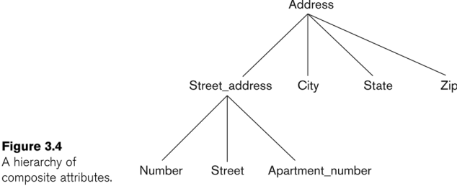Copyright © 2017 Ramez Elmasri and Shamkant B. Navathe Slide 3- 7
Entity Types and Key Attributes (1)
■ Entities with the same basic attributes are grouped or typed into an entity type.
■ For example, the entity type EMPLOYEE and PROJECT. ■ An attribute of an entity type for which each entity must have a unique value is called a key attribute of the entity type. ■ For example, SSN of EMPLOYEE.
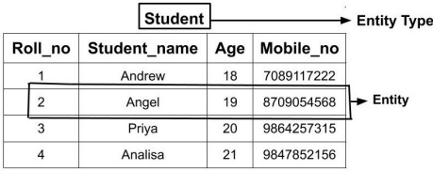
Copyright © 2017 Ramez Elmasri and Shamkant B. Navathe Slide 3- 8
Entity Types and Key Attributes (2)
■ A key attribute may be composite.
■ VehicleTagNumber is a key of the CAR entity type with components (Number, State).
■ An entity type may have more than one key.
■ The CAR entity type may have two keys:
■ VehicleIdentificationNumber (popularly called VIN)
■ VehicleTagNumber (Number, State), aka license plate number.
■ Each key is underlined (Note: this is different from the relational schema where only one “primary key is underlined).
Copyright © 2017 Ramez Elmasri and Shamkant B. Navathe Slide 3- 9
Entity Set, Value Sets(Domains) of Attributes
■ Each entity type will have a collection of entities stored in the database ■ Called the entity set or sometimes entity collection
■ Entity set is the current state of the entities of that type that are stored in the database
■ Each simple attribute is associated with a value set(Domain) ■ E.g., Lastname has a value which is a character string of upto 15 characters, say
■ Date has a value consisting of MM-DD-YYYY where each letter is an integer
■ A value set specifies the set of values associated with an attribute ■ Value sets are similar to data types in most programming languages – e.g., integer, character (n), real, bit
Copyright © 2017 Ramez Elmasri and Shamkant B. Navathe Slide 3- 10
Displaying an Entity type
■ In ER diagrams, an entity type is displayed in a rectangular box ■ Attributes are displayed in ovals
■ Each attribute is connected to its entity type
■ Components of a composite attribute are connected to the oval representing the composite attribute
■ Each key attribute is underlined
■ Multivalued attributes displayed in double ovals
Copyright © 2017 Ramez Elmasri and Shamkant B. Navathe Slide 3- 11
NOTATION for ER diagrams
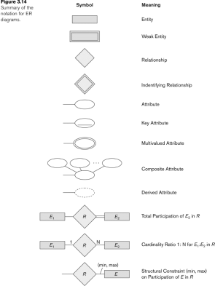
Copyright © 2017 Ramez Elmasri and Shamkant B. Navathe Slide 3- 12
Entity Type CAR with two keys and a corresponding Entity Set
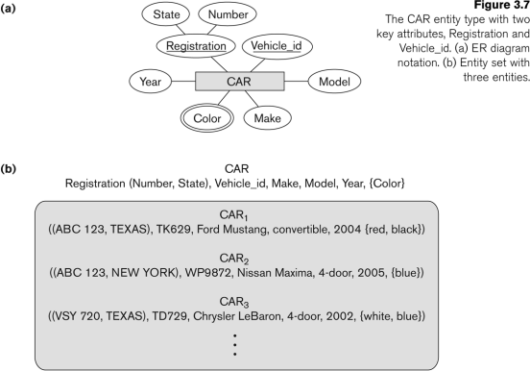Copyright © 2017 Ramez Elmasri and Shamkant B. Navathe Slide 3- 13
Initial Conceptual Design of Entity Types for the COMPANY Database Schema
■ Based on the requirements, we can identify four initial entity types in the COMPANY database:
■ DEPARTMENT
■ PROJECT
■ EMPLOYEE
■ DEPENDENT
Copyright © 2017 Ramez Elmasri and Shamkant B. Navathe Slide 3- 14
Initial Design of Entity Types:
EMPLOYEE, DEPARTMENT, PROJECT, DEPENDENT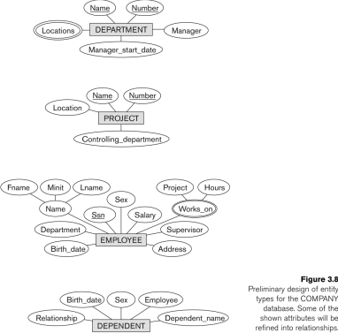
Copyright © 2017 Ramez Elmasri and Shamkant B. Navathe Slide 3- 15
Refining the initial design by introducing relationships
■ The initial design is typically not complete
■ Some aspects in the requirements will be represented as relationships
■ ER model has three main concepts:
■ Entities (and their entity types and entity sets)
■ Attributes (simple, composite, multivalued)
■ Relationships (and their relationship types and relationship sets)
Copyright © 2017 Ramez Elmasri and Shamkant B. Navathe Slide 3- 16
Relationships and Relationship Types (1)
■ A relationship relates two or more distinct entities with a specific meaning.
■ For example, EMPLOYEE John Smith works on the ProductX PROJECT, or EMPLOYEE Franklin Wong manages the Research DEPARTMENT.
■ Relationships of the same type are grouped or typed into a relationship type.
■ For example, the WORKS_ON relationship type in which EMPLOYEEs and PROJECTs participate, or the MANAGES relationship type in which EMPLOYEEs and DEPARTMENTs participate.
■ The degree of a relationship type is the number of participating entity types.
■ Both MANAGES and WORKS_ON are binary relationships.
Copyright © 2017 Ramez Elmasri and Shamkant B. Navathe Slide 3- 17
Relationship instances of the WORKS_FOR N:1 relationship between EMPLOYEE and DEPARTMENT
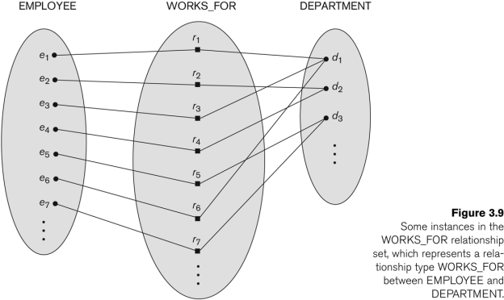Copyright © 2017 Ramez Elmasri and Shamkant B. Navathe Slide 3- 18
Relationship instances of the M:N WORKS_ON relationship between EMPLOYEE and PROJECT
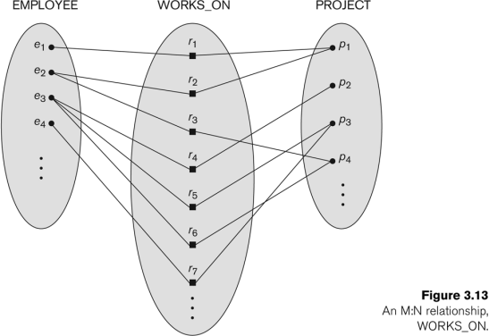Copyright © 2017 Ramez Elmasri and Shamkant B. Navathe Slide 3- 19
Relationship type vs. relationship set (1)
■ Relationship Type:
■ Is the schema description of a relationship
■ Identifies the relationship name and the participating entity types ■ Also identifies certain relationship constraints
■ Relationship Set:
■ The current set of relationship instances represented in the database
■ The current state of a relationship type
Copyright © 2017 Ramez Elmasri and Shamkant B. Navathe Slide 3- 20
Relationship type vs. relationship set (2)
■ Previous figures displayed the relationship sets ■ Each instance in the set relates individual participating entities – one from each participating entity type
■ In ER diagrams, we represent the relationship type as follows: ■ Diamond-shaped box is used to display a relationship type ■ Connected to the participating entity types via straight lines ■ Note that the relationship type is not shown with an arrow. The
name should be typically be readable from left to right and top to bottom.
Copyright © 2017 Ramez Elmasri and Shamkant B. Navathe Slide 3- 21
Refining the COMPANY database schema by introducing relationships
■ By examining the requirements, six relationship types are identified
■ All are binary relationships( degree 2)
■ Listed below with their participating entity types: ■ WORKS_FOR (between EMPLOYEE, DEPARTMENT) ■ MANAGES (also between EMPLOYEE, DEPARTMENT) ■ CONTROLS (between DEPARTMENT, PROJECT) ■ WORKS_ON (between EMPLOYEE, PROJECT) ■ SUPERVISION (between EMPLOYEE (as subordinate), EMPLOYEE (as supervisor))
■ DEPENDENTS_OF (between EMPLOYEE, DEPENDENT)
Copyright © 2017 Ramez Elmasri and Shamkant B. Navathe Slide 3- 22
ER DIAGRAM – Relationship Types are: WORKS_FOR, MANAGES, WORKS_ON, CONTROLS, SUPERVISION, DEPENDENTS_OF
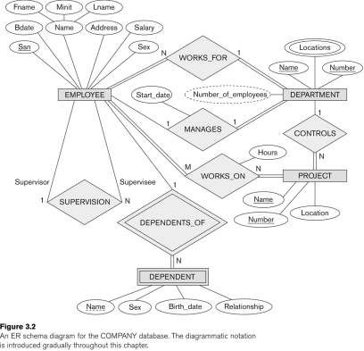
Copyright © 2017 Ramez Elmasri and Shamkant B. Navathe Slide 3- 23
Discussion on Relationship Types
■ In the refined design, some attributes from the initial entity types are refined into relationships:
■ Manager of DEPARTMENT -> MANAGES
■ Works_on of EMPLOYEE -> WORKS_ON
■ Department of EMPLOYEE -> WORKS_FOR
■ etc
■ In general, more than one relationship type can exist between the same participating entity types
■ MANAGES and WORKS_FOR are distinct relationship types between EMPLOYEE and DEPARTMENT
■ Different meanings and different relationship instances.
Copyright © 2017 Ramez Elmasri and Shamkant B. Navathe Slide 3- 24
Constraints on Relationships
■ Constraints on Relationship Types(known as ratio constraints) ■ Cardinality Ratio (specifies maximum participation) ■ One-to-one (1:1)
■ One-to-many (1:N) or Many-to-one (N:1)
■ Many-to-many (M:N)
■ Existence Dependency Constraint (specifies minimum participation) (also called participation constraint) ■ zero (optional participation, not existence-dependent) ■ one or more (mandatory participation, existence-dependent)
Copyright © 2017 Ramez Elmasri and Shamkant B. Navathe Slide 3- 25
Many-to-one (N:1) Relationship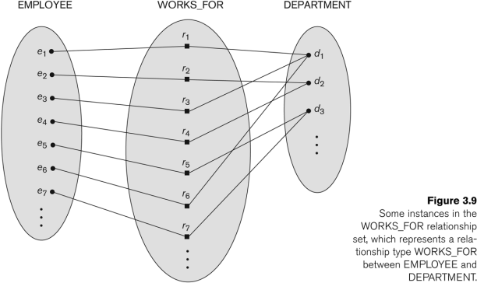Copyright © 2017 Ramez Elmasri and Shamkant B. Navathe Slide 3- 26
Many-to-many (M:N) Relationship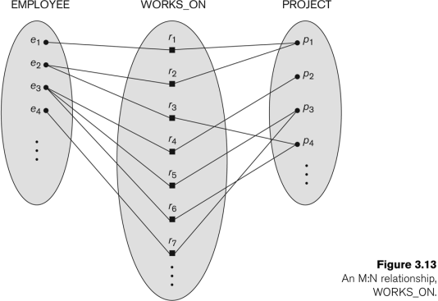Copyright © 2017 Ramez Elmasri and Shamkant B. Navathe Slide 3- 27
Recursive Relationship Type
■ A relationship type between the same participating entity type in distinct roles
■ Also called a self-referencing relationship type.
■ Example: the SUPERVISION relationship
■ EMPLOYEE participates twice in two distinct roles: ■ supervisor (or boss) role
■ supervisee (or subordinate) role
■ Each relationship instance relates two distinct EMPLOYEE entities: ■ One employee in supervisor role
■ One employee in supervisee role
Copyright © 2017 Ramez Elmasri and Shamkant B. Navathe Slide 3- 28
Displaying a recursive
relationship
■ In a recursive relationship type.
■ Both participations are same entity type in different roles.
■ For example, SUPERVISION relationships between EMPLOYEE (in role of supervisor or boss) and (another) EMPLOYEE (in role of subordinate or worker).
■ In following figure, first role participation labeled with 1 and second role participation labeled with 2.
■ In ER diagram, need to display role names to distinguish participations.
Copyright © 2017 Ramez Elmasri and Shamkant B. Navathe Slide 3- 29
A Recursive Relationship Supervision`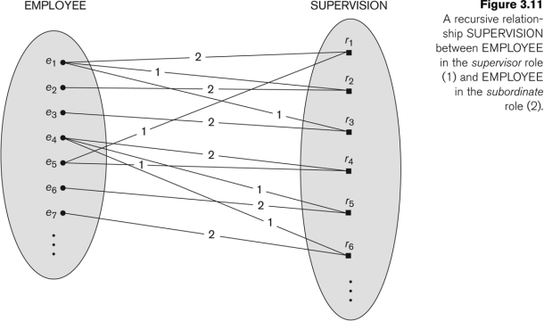Copyright © 2017 Ramez Elmasri and Shamkant B. Navathe Slide 3- 30
Recursive Relationship Type is: SUPERVISION (participation role names are shown)
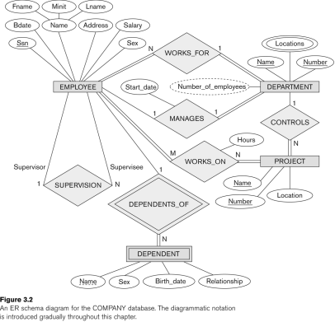
Copyright © 2017 Ramez Elmasri and Shamkant B. Navathe Slide 3- 31
Weak Entity Types
■ An entity that does not have a key attribute and that is identification dependent on another entity type.
■ A weak entity must participate in an identifying relationship type with an owner or identifying entity type
■ Entities are identified by the combination of:
■ A partial key of the weak entity type
■ The particular entity they are related to in the identifying relationship type
■ Example:
■ A DEPENDENT entity is identified by the dependent’s first name, and the specific EMPLOYEE with whom the dependent is related ■ Name of DEPENDENT is the partial key
■ DEPENDENT is a weak entity type
■ EMPLOYEE is its identifying entity type via the identifying relationship type DEPENDENT_OF
Copyright © 2017 Ramez Elmasri and Shamkant B. Navathe Slide 3- 32
Attributes of Relationship types
■ A relationship type can have attributes:
■ For example, HoursPerWeek of WORKS_ON
■ Its value for each relationship instance describes the number of hours per week that an EMPLOYEE works on a PROJECT. ■ A value of HoursPerWeek depends on a particular (employee, project) combination
■ Most relationship attributes are used with M:N relationships ■ In 1:N relationships, they can be transferred to the entity type on the N-side of the relationship
Copyright © 2017 Ramez Elmasri and Shamkant B. Navathe Slide 3- 33
Example Attribute of a Relationship Type: Hours of WORKS_ON
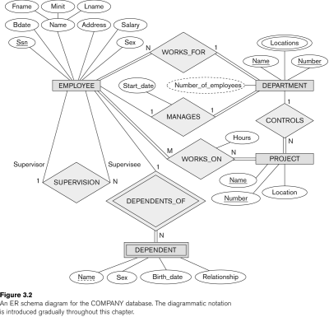
Copyright © 2017 Ramez Elmasri and Shamkant B. Navathe Slide 3- 34
Notation for Constraints on
Relationships
■ Cardinality ratio (of a binary relationship): 1:1, 1:N, N:1, or M:N ■ Shown by placing appropriate numbers on the relationship edges. ■ Participation constraint (on each participating entity type): total (called existence dependency) or partial.
■ Total shown by double line, partial by single line.
Copyright © 2017 Ramez Elmasri and Shamkant B. Navathe Slide 3- 35
Alternative (min, max) notation for relationship structural constraints:
■ Specified on each participation of an entity type E in a relationship type R
■ Specifies that each entity e in E participates in at least min and at most max relationship instances in R
■ Default(no constraint): min=0, max=n (signifying no limit) ■ Must have min≤max, min≥0, max ≥1
■ Derived from the knowledge of mini-world constraints ■ Examples:
■ A department has exactly one manager and an employee can manage at most one department.
■ Specify (0,1) for participation of EMPLOYEE in MANAGES ■ Specify (1,1) for participation of DEPARTMENT in MANAGES ■ An employee can work for exactly one department but a department can have any number of employees.
■ Specify (1,1) for participation of EMPLOYEE in WORKS_FOR ■ Specify (0,n) for participation of DEPARTMENT in WORKS_FOR
Copyright © 2017 Ramez Elmasri and Shamkant B. Navathe Slide 3- 36
The (min,max) notation for
relationship constraints
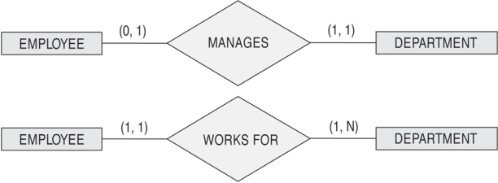
Read the min,max numbers next to the entity type and looking away from the entity type
Copyright © 2017 Ramez Elmasri and Shamkant B. Navathe Slide 3- 37
COMPANY ER Schema Diagram using (min, max) notation
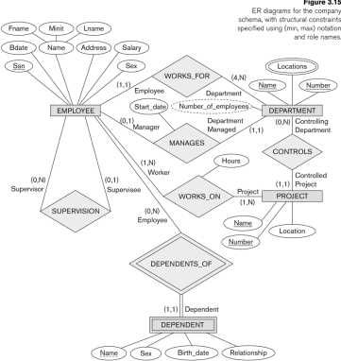
Copyright © 2017 Ramez Elmasri and Shamkant B. Navathe Slide 3- 38
Summary of notation for ER diagrams
Copyright © 2017 Ramez Elmasri and Shamkant B. Navathe Slide 3- 39
Other alternative diagrammatic notations
Copyright © 2017 Ramez Elmasri and Shamkant B. Navathe Slide 3- 40
Relationships of Higher Degree ■ Relationship types of degree 2 are called binary
■ Relationship types of degree 3 are called ternary and of degree n are called n-ary
■ In general, an n-ary relationship is not equivalent to n binary relationships
■ Constraints are harder to specify for higher-degree relationships (n > 2) than for binary relationships
Copyright © 2017 Ramez Elmasri and Shamkant B. Navathe Slide 3- 41
Some of the Automated Database
Design Tools (Note: Not all may be on the market now)
COMPANY | TOOL | FUNCTIONALITY
Embarcadero Technologies | ER Studio | Database Modeling in ER and IDEF1X
Embarcadero Technologies | DB Artisan | Database administration, space and security management
Oracle | Developer 2000/Designer 2000 | Database modeling, application development
Popkin  Software | System Architect 2001 | Data modeling, object modeling, process modeling, structured analysis/design
Platinum  (Computer  Associates) | Enterprise Modeling Suite: Erwin, BPWin, Paradigm Plus | Data, process, and business component modeling
Persistence  Inc. | Pwertier | Mapping from O-O to relational model
Rational (IBM) | Rational Rose | UML Modeling & application generation in C++/JAVA
Resolution Ltd. | Xcase | Conceptual modeling up to code maintenance
Sybase | Enterprise Application Suite | Data modeling, business logic modeling
Visio | Visio Enterprise | Data modeling, design/reengineering Visual Basic/C++

Copyright © 2017 Ramez Elmasri and Shamkant B. Navathe Slide 3- 42

